Assignment .
Course: Gen AI Test Tool Developer [AI Agentic Workflows]
Topic: LangChain & LangGraph .
Live Session Date: 21st March 2026

Using the Langflow-
- Develop a Workflow to read the document and extract the required data
- We can add multiple documents.
- Integrate the Workflow by using an API call by Postman

Building a Langflow RAG-Style Extraction Pipeline
“Document Reader & Data Extractor with API Call”

LangFlow Workflow Components:
- Files = Context (unstructured data source)
- Chat Input = Query / Extraction instruction
- Prompt Template = Orchestration logic (VERY critical)
- The Prompt Template is the core intelligence layer here.
- It determines how accurately your workflow extracts data.
- LLM (Groq) = Reasoning + Extraction
- Output = Structured result

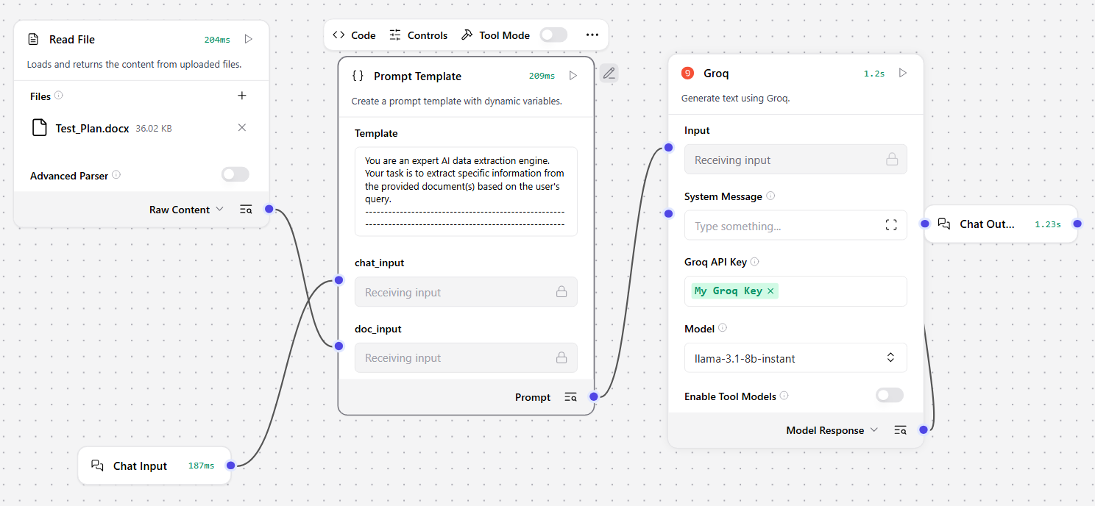

For the 3rd Component ‘Prompt Template’, the following prompt is used:

You are an expert AI data extraction engine.
Your task is to extract specific information from the provided document(s) based on the user's query.
-------------------------------------------------------------------------------------------------------------------------
📄 DOCUMENT CONTENT:
{doc_input}
-------------------------------------------------------------------------------------------------------------------------
📌 USER QUERY:
{chat_input}
-------------------------------------------------------------------------------------------------------------------------
🎯 INSTRUCTIONS:
1. Carefully read the user query and understand what data needs to be extracted.
2. Analyze the document content thoroughly.
3. Extract ONLY the relevant information that directly answers the query.
4. If multiple documents are provided, combine and reconcile the information.
5. If the answer is not found, respond with: "Data not found in the provided document(s)."
-------------------------------------------------------------------------------------------------------------------------
📦 OUTPUT FORMAT RULES:
- Provide a clear, structured response
- Use bullet points or JSON format wherever applicable
- Do NOT include irrelevant text
- Do NOT hallucinate or assume missing data
-------------------------------------------------------------------------------------------------------------------------
✅ FINAL OUTPUT: Show ONLY the Output; NOT the above prompt

Now, in the LangFlow, the Input Schema for the ‘Prompt Template’ has been modified to customizable.
This means now the Prompt can be changed/modified in the Postman as well.

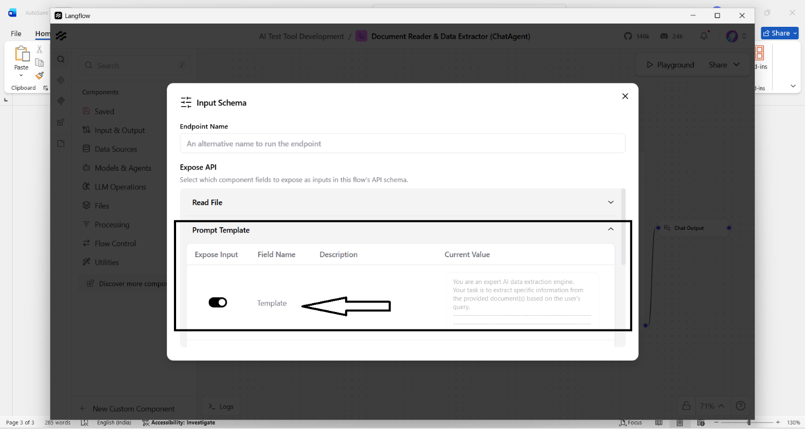

Integrating the LangFlow Workflow by using an API call by Postman .

